# For While Do while Break Continue Assignment

1. **WAP to read a number n and to display the cumulative sum of factorial of all numbers upto n . (use for or while)**

**Input: 4**

**Ouput: 4!+3!+2!+1! = 32**

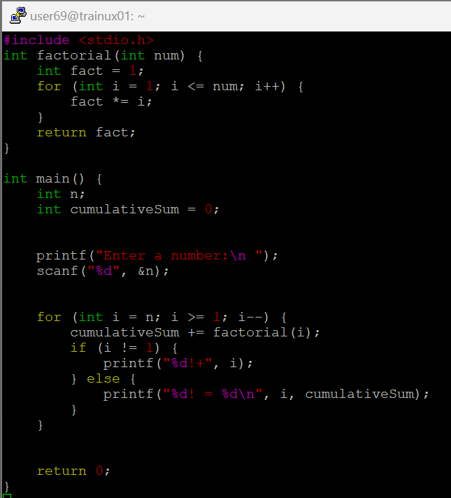

1. **Write a program to accept “N” integers from the user. “N” also has to be taken from the user. Take the count of +ve numbers, -ve numbers and 0’s.**

**However the program should not accept a non-integer value. If a non-integer value is entered, used must be asked to re-enter.**

**[Hint:**

* 1. **Use the return value of scanf to find out whether the user has entered integer or not.**
  2. **You also will have to clear the input buffer before taking the next input.**

**For clearing the input buffer, use one of the following approaches**

* **while (getchar() != '\n'); // keep reading till newline and discard the characters**
* **scanf(“%*s”); // read and discard one string**

**]**

1. **Write a program to continuously read a string of maximum length 80 chars, End the program if string is END, else convert to upper case, display and continue. (use while)**

1. **Refer the program “value_out_of_domain.c”. Try to run the program with a large value say 255. Check the output? Is it correct? Fix the issue observed.**

**What improvements do you suggest?**

The factorial of 255 is a huge value which cannot be stored in int type which holds only 4 bytes with a range of -2,147,483,648 to 2,147,483,647. So store such a large values we need to define an array with large size like array[1000] that holds the value.

1. **Refer the code below. It does not output anything. Fix it.**

#include <stdio.h>

int main()

{

int x = 5;

while (x > 0);

{

printf( "Value of x :%d \n", x);

x--;

}

return 0;

}

There is a semicolon at the end of while loop. Here the while condition will gets executed continuously and do not enter the block. Therefore the code doesnot give any output.

1. **Analyse the code, identify the issues**

#include <stdio.h>

int main()

{

float cnt = 0, num = 1000;

do

{

printf ("\n%d\n%d", num,cnt);

num /= cnt;

} while (cnt --); /* End of while */

return 0;

}

The variables cnt and num are declared as floats but they are given format specifiers as %d. It can be rectified by taking %f as format specifiers.